CSE 370 , Lab Homework 1

1. mysql -u root –p

create database project;

show databases;

use project;

create table Developers(

-> member_id char(4),

-> name varchar(30),

-> email char(30),

-> influence_count int,

-> Joining_date date,

-> multiplier int

-> );

insert into Developers (member_id,name,email,influence_count,Joining_date,multiplier) values ("1","Taylor Otwell","otwell@laravel.com",739360,"2020-6-10",10);

insert into developers values ("2","Ryan Dahl","ryan@nodejs.org",633632,"2020-04-22",10);

insert into developers values ("3","Brendan Eich","eich@javascript.com",939570,"2020-05-07",8),("5","Evan You","you@vuejs.org",982630,"2020-06-11",7),("6","Rasmus Lerdorf","lerdorf@php.net",937927,"2020-06-3",8),("7","Guido van Rossum","guido@python.org",968827,"2020-07-18",19),("8","Adrian Holovaty","adrian@djangoproject.com",570724,"2020-05-07",5),("9","Simon Willison","simon@djangoproject.com",864615,"2020-04-30",4),("10","James Gosling","james@java.com",719491,"2020-05-18",5),("11","Rod Johnson","rod@spring.io",601744,"2020-05-18",7),("12","Satoshi Nakamoto","nakamoto@blockchain.com",630488,"2020-05-10",10);

SELECT * FROM developers;

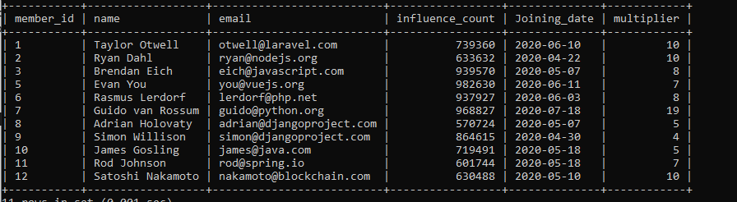

2 ) ALTER TABLE developers CHANGE influence_count followers int;

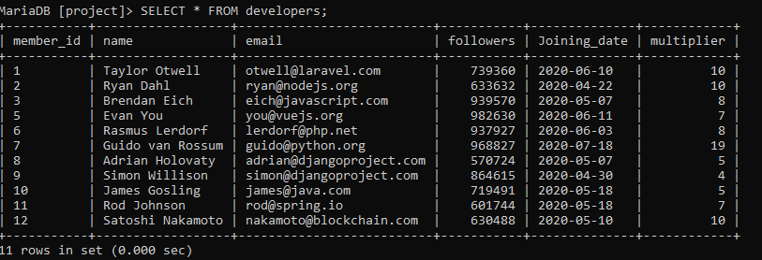

3 ) UPDATE developers SET followers = followers+10;

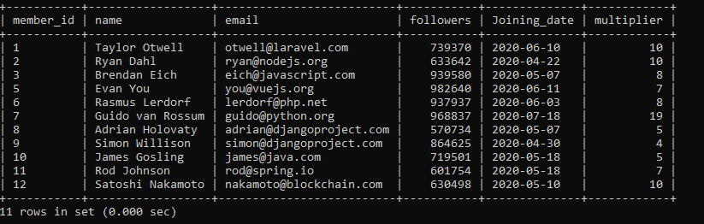

4 ) SELECT name,email,followers FROM developers;

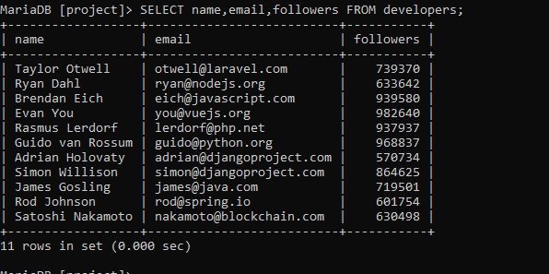

5 ) SELECT name, ((followers*100/1000000)*(multiplier*100/20))/100 AS Efficiency FROM developers;

